I’ve completed phase 1 to include all of my design plans, which include the GUI and algorithm for the snake movements. Our main java code enables us to launch games quickly via the gui interface. Refer to figure 1.1.

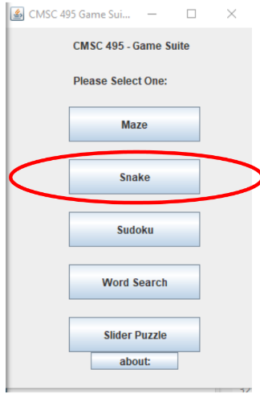 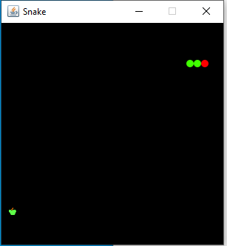

Figure 1.1

I’m currently modifying speeds to see which setting best fits the tempo of the game. I’ve also programed the maneuvering keys so players can take control of the snake. Next steps will include coding an out of bounds feature that players can’t cross and will trigger an automatic game over if crossed. Refer to figure 1.2.

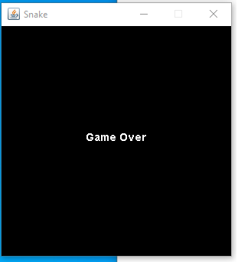

Figure 1.2